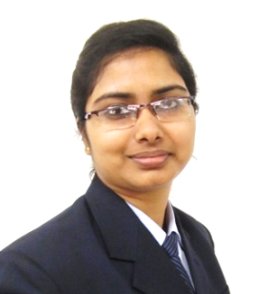

**ANJUSHA DASGUPTA**

**Contact No:** +91-9831764340

**E-Mail ID:** anjusha.dasgupta90@gmail.com

Looking for a responsible position of the Corporate Recruiter in the well-established organization with a view to apply my knowledge and skills for the organizational development as well as a rewarding career. I would like to point out that I have done MBA with major specialization in Human Resources.

* + - * Working with **SMVA Consultants** as **Team Leader (Recruitment)**

**Work**

**Experience**

(December 2016 to till Date)

* + - * Worked with **Adfers Consultants LLP** as **Sr. Resource Consultant**

(July 2015 to November 2016)

* Sourcing and screening of CVs from job portals as well as through Social Networking platforms.
* Understanding the client requirement and shortlisting CVs matching up the requirements of the clients.

**Work Profile Summary**

* Responsible for cold calling and lining up of candidates for interview with client companies.
* Responsible for calling and educating probable candidates regarding job description and Client Company profile.
* Managing a team of recruiters for sourcing and screening of profiles.
* Coordinating with clients regularly for interviews and candidate line-up.
* Follow-up with clients for interview feedback and closure of position.
* Managing interview schedules and follow-ups.
* MBA (HR + Marketing) from WBUT (2015) with DGPA 7.97

**Education Record**

* B.Sc. (Computer Science) from University of Calcutta
* Higher Secondary (Science) from W.B.C.H.S.E
* Madhyamik from W.B.B.S.E.
* Summer Internship Project on Compensation Management (UMPL).

**Project & Report**

* Industry Visit Report (ntc industries limited).

**Summer Training (SIP):-**

|  |  |
| --- | --- |
| Project Title: | Compensation Management System |
| Duration: | 2 months |
| Organization | Unnati Management Private Limited, HO, Kolkata. |
| Learnings | 1: Salary processing of an organization  2: Attendance management.  3: The general Statutory payments applicable to an organization.  4: Leave calculation |

**Technical Skills: -**

MS Windows, MS Office (Word, Excel, PowerPoint), well versed with Internet and E-Mail.

**Languages Known:-**

* English
* Hindi
* Bengali

**Interests:-**

* Travelling, Singing& Listening to Soft Music.

**Personal details:-**

* Father’s Name: Mr. Anup Dasgupta
* Mother’s Name: Mrs. Sipra Dasgupta
* Date of Birth: 04/10/1990
* Mailing Address: 42/A, Ishwar Chatterjee Road,

Ava Apartment 2, Flat No: A1, Kundubagan,

Sukchar, Sodepur, Kolkata-700115

**Declarations:-**

I do hereby declare that the information provided here are true to the best of my knowledge and belief.

**ANJUSHA DASGUPTA**